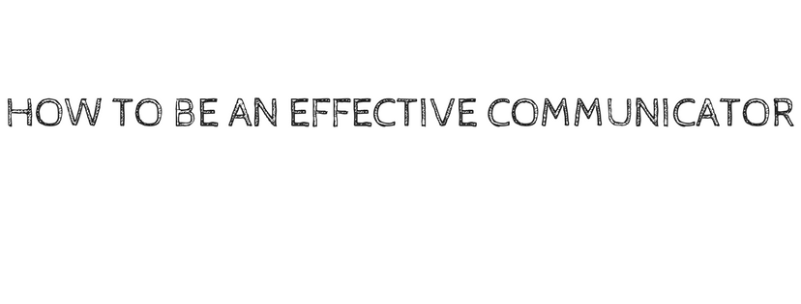

Everyone communicates in one way or another, but very few people have mastered the skill of truly effective communication. Breakdowns in communication occur all too often and usually lead to a wide range of problems.

Communication is both an expressive, message-sending, and a receptive, message-receiving process. Failure to communicate effectively can be due to a problem on either or both ends of the process.

**Tips for effective expressive (speaking) communication:**

* When speaking make sure you have the attention of the other person
* Try to send a clear, consistent message
* Say what you mean and mean what you say
* Ask for feedback to be sure you were understood
* Putting something in writing provides you a paper trail

**Aggressive communication is based on winning.**

You do what is in your best interest without regard for the rights, needs, feelings, or desires of other people. When you are aggressive, the power you use is selfish. You may come across as pushy or even bullying. You take what you want, often without asking.

***Anyone can become an assertive communicator but it takes practice. This is something you can practice and master at home either by yourself or with a family member or friend. Becoming more assertive does not mean that you will always get what you want but it gives you the best chance of being understood and if need be to achieve a compromise.***

**Tips for effective receptive (listening) communication:**

* When listening, face the person speaking and maintain eye contact
* Listen to what they are saying
* Let them finish their thought without interrupting
* Ask clarifying questions if needed
* Paraphrase what you heard to be sure you understood

**There are four basic communication styles:**

* Passive – avoid expressing your opinions and feelings
* Aggressive – expressing your opinion in a way that violates other’s rights
* Passive-aggressive – appear passive but acting out anger in subtle ways
* Assertive – expressing your opinion firmly without violating the other’s rights

Being assertive means respecting yourself and other people. It is the ability to clearly express your thoughts and feelings through open, honest and direct communication. All of the tips listed above for effective communication, are traits of assertive communicators.